**Activity diagram of college voting system:**

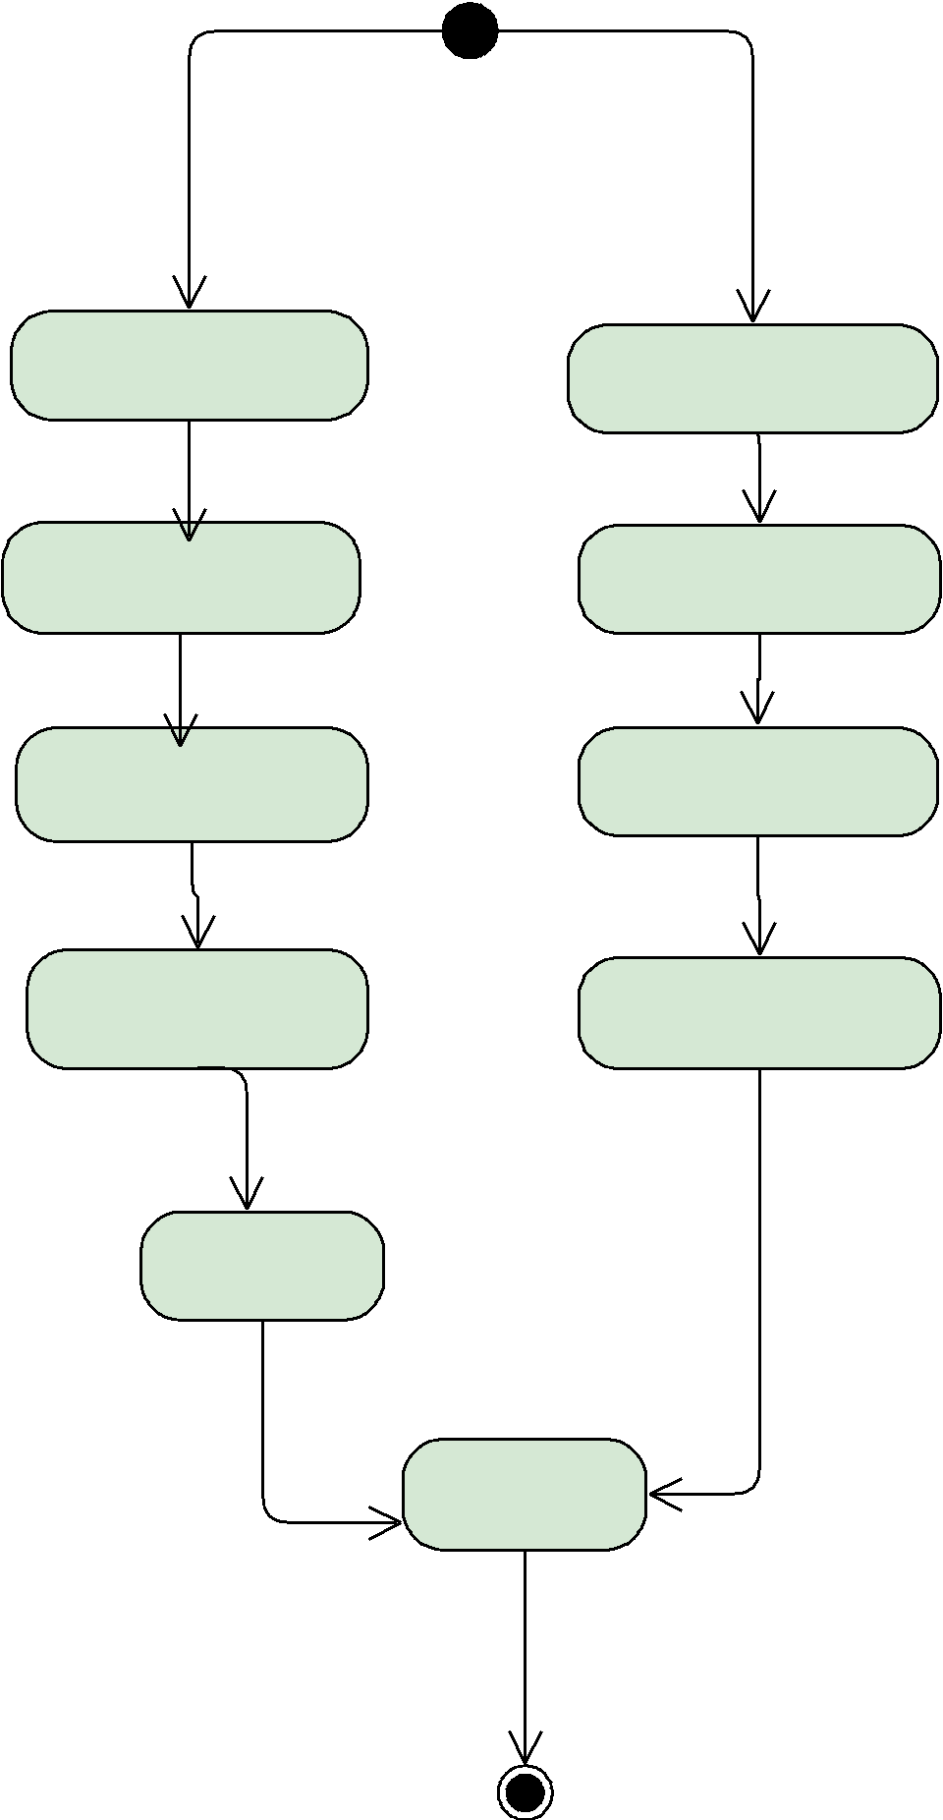

|  |  |  |
| --- | --- | --- |
| admin | voters |  |
|  |  |

login login

add candidates view candidates

view candidates vote

view students

results

**Class diagram of college voting system:**

admin:varchar

**Admin**

username:varchar

**Voter**

password:Varchar

+login ( )

+add candidates ( )

+view candidates ( )

+view voters ( )

+results graph ( )

+logout ( )

password:vharchar

+register ( )

+login ( )

+vote ( )

+logout ( )

1/1

1/1